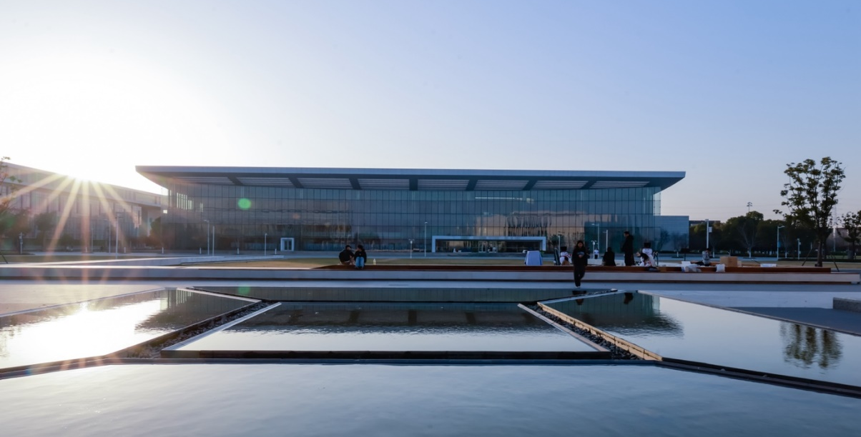
Duke Kunshan University Enhances Campus-wide Audio Experience with 116 units of Sennheiser TeamConnect Ceiling 2
TCC 2 Ushers in a New Era of Immersive Audio Experience at Duke Kunshan University

Kunshan, China, 25 April 2024 — Duke Kunshan University, a renowned global institution with innovative academic programs and an internationally diverse faculty, has set exceptionally high standards for hybrid smart education. Across its campus, the university has equipped 50 multifunctional classrooms and spaces with a total of 116 units of Sennheiser TeamConnect Ceiling 2 (TCC 2). These TCC 2s offer an exceptional hybrid learning experience, characterized by superior sound quality and efficient setup.

Located in Kunshan, China, Duke Kunshan University is a world-class, research-oriented educational institution with a strong focus on liberal arts and sciences. Set within an expansive 80-hectare campus, the university offers a broad spectrum of high-quality and innovative academic programs. It provides an inclusive and multicultural environment for students from around the world, with the objective of nurturing future leaders across disciplines.

The Duke Kunshan University project is the university’s Phase 2 deployment of audio-video system. It is a large scale project that involves implementation of solutions across 22 buildings, covering 29 classrooms, 20 conference rooms, as well as a visitors centre. After considering several top global brands, Duke Kunshan University selected Sennheiser’s TCC 2, which stood out for its state-of-the-art audio technology, brand agnostic integration, and a proven track record of successful global applications. With the installation of 116 units of TCC 2 throughout the campus, the university ensured that every space could benefit from the Trusted Sennheiser Audio Quality.

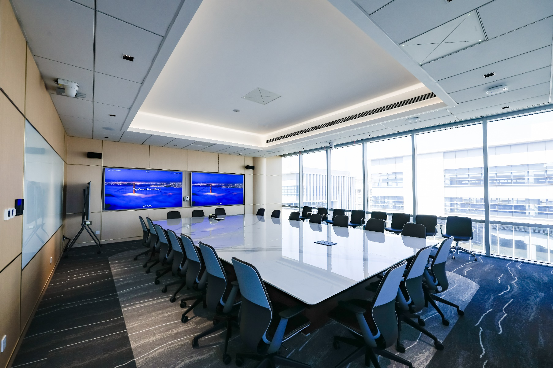
With the installation of 116 units of TCC 2 throughout the campus, the university ensured that every space could benefit from the Trusted Sennheiser Audio Quality

Hybrid Teaching and Remote Conferencing Experience Powered by Unparalleled Audio Quality

The classes at Duke Kunshan University are taught by, not only locally based professors, but also professors from Duke University in the United States and many others from across the globe. Therefore, one of the school’s requirements for this project was to make sure that all the classrooms could support a hybrid learning experience. The university was especially particular about the audio system – they wanted crystal clear sound quality delivered by a stable and reliable system, ease of operation and, last but not least, a flexible system that can be used in different room types, configurations and learning environments.

TCC 2, equipped with patented dynamic beamforming technology, can automatically identify speakers' positions, and seamlessly switch between different speakers in real-time, ensuring clear voice capture. Lecturers now have freedom of movement and can interact with students freely. This technology also offers flexibility in arranging classroom layouts, which greatly enhances the learning experience. Its 28 integrated broadcast-level microphone capsules ensure superb speech intelligibility. The remote participants can hear the speakers as if they were in a face-to-face interaction.

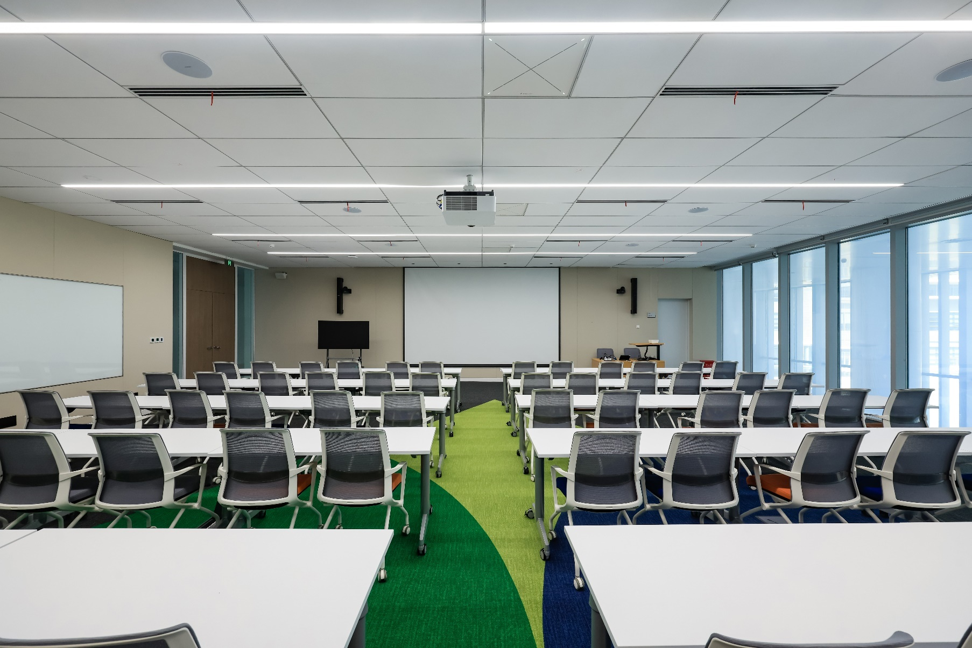
TCC 2’s beamforming technology can automatically detect the speakers’ positions and switch between different speakers in real-time, significantly enhancing the overall flexibility and learning experience

In addition to classrooms, Duke Kunshan University also placed a great emphasis on the audio and visual system design and integration in its conference rooms, where virtual meetings are conducted. For this project, the TCC 2 is integrated with the Biamp DSP and the Sony PTZ camera tracking functionality to synchronise the speaker’s location with the cameras. Consequently, real-time camera-switching based on speaker changes becomes possible, which delivers a more realistic, efficient, and immersive experience.

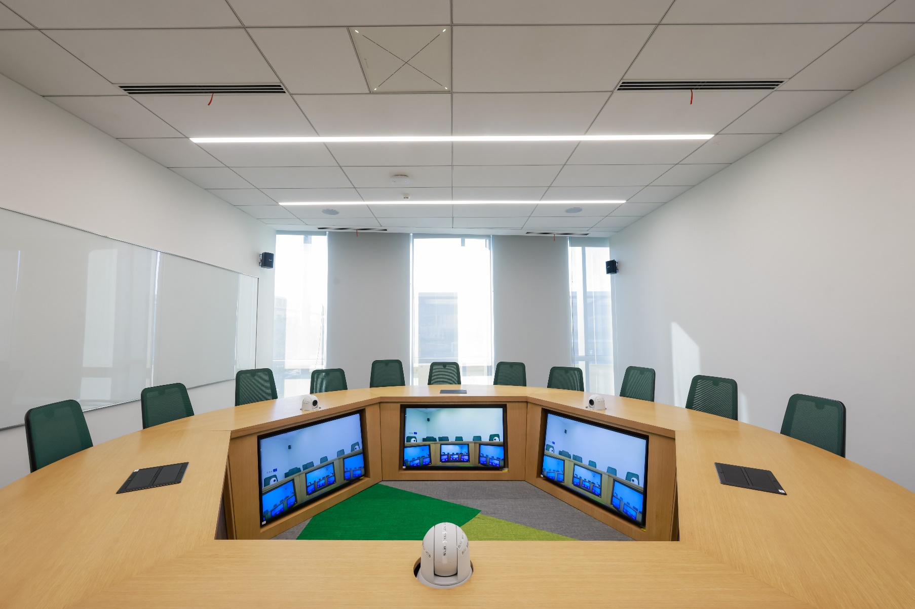
TCC 2 synchronises the speaker’s location with the cameras to achieve real-time camera-switching, delivering more realistic, efficient and immersive experience

Another highlight of this project is the visitors centre. The university constructed this spacious facility that spans an area of 400 square metres and stands 4.8 metres tall to encourage exchanges between professors and students. The centre was also designed to be a flexible space that could be configured to serve as an event and exhibition area. For this space, the school wanted not just high quality audio for conferencing use, but also a system that could elevate in-room audio capabilities. To fulfil this requirement, 3 units of TCC 2 were installed in the visitors centre. The TruVoicelift functionality guarantees that everyone’s voice can be heard clearly from every corner of the room, without any distortion or delays.

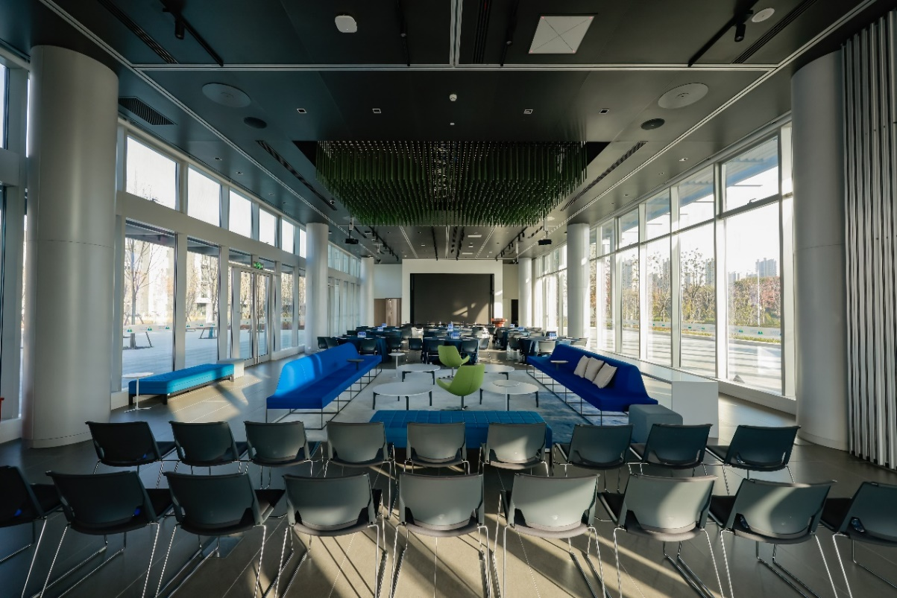
TCC 2’s TruVoicelift functionality guarantees that everyone’s voice can be heard clearly from every corner of the room, without any distortion or delays

Simplified Workflows and Brand Agnostic Ecosystem
It took the Duke Kunshan University three years to complete this Phase 2 deployment from design to complete implementation. Besides it being a large-scale project, it is also incredibly complex, since an extensive variety of products from different brands, such as Biamp DSP, Bose speakers and a Crestron control system, had to be integrated. Therefore, seamless product integration at every stage and simplified workflows were crucial. This is also the principal challenge that the team at the Duke Kunshan University faced.

William Wan, the Chief Engineer at Duke Kunshan University, oversaw the audio system design. His team developed a fully digital and distributed AV-over-IP architecture for the campus. Based on Dante, TCC 2 is seamlessly integrated into the campus network, together with audio equipment from various brands. This allows the IT manager to monitor and control a variety of different devices across the campus in real-time, through mobile tablets or desktop devices. This substantially simplifies the workflow, while ensuring reliable performance.

Sennheiser Global Alliances is founded on its brand-agnostic approach, which ensures maximum flexibility for customers. Platform certifications play a crucial role in this approach, as they guarantee seamlessly interoperability of Sennheiser products with platforms for which they are certified. The TCC 2 is certified for use with numerous mainstream video conferencing platforms, including Microsoft Teams, Zoom, Tencent Meeting, and DingTalk Meeting. This satisfies the diverse preferences and needs of various users.

Customer-Centric Professional Services Guarantee Successful Implementation.

Throughout the course of the project, Sennheiser engineers made numerous visits to the site, meticulously working and adjusting room by room to ensure optimal placement and angling of every TCC 2 to achieve the best speech intelligibility.

"The exceptional quality of the TCC 2 is unquestionable. The Sennheiser team also played a significant role in the successful execution of the project. The comprehensive technical and training support that Sennheiser provided contributed greatly to our progress and success in tuning and optimizing the system, " Wan remarked.

"For future development plans, we look forward to continue working with Sennheiser to further enhance our audio-video facilities, thereby enhancing the immersive learning and collaboration experience for our educators and students,” Wan continued.

Sennheiser will continue to pay close attention to the evolving trends and shifting requirements of the education sector and is committed to shaping the future of audio for smart education, with continuous innovation, unparallel audio products and cutting-edge technologies.

About the Sennheiser brand
We live and breathe audio. We are driven by the passion to create audio solutions that make a difference. Building the future of audio and bringing remarkable sound experiences to our customers – this is what the Sennheiser brand has represented for more than 75 years. While professional audio solutions such as microphones, meeting solutions, streaming technologies and monitoring systems are part of the business of Sennheiser electronic GmbH & Co. KG, the business with consumer devices such as headphones, soundbars and speech-enhanced hearables is operated by Sonova Holding AG under the license of Sennheiser.

www.sennheiser.com
www.sennheiser-hearing.com

